Cell Differentiation – Notes
Blastocyst structure:
- Inner cell mass – around 30 cells that make up the embryo.
- One of the sources of stem cells.
- Trophoblast – Layer of cells surrounding the inner cell mass and blastocyst cavity that will end up making the placenta.

Stem cell characteristics:
- Are said to be undifferentiated – they aren’t specialised (yet) for any particular task.
- The stem cells from the inner cell mass end up differentiating into the 200 different types of adult cells.
- They can proliferate – divide by mitosis to make more stem cells or differentiate.
- They can differentiate into specialised cells given the right conditions.

Stem cell potency:
- Potency refers to the extent at which a stem cell can differentiate into a type of cell.
- The higher the potency the greater the range of types of cells the stem cell can specialise into.

Potency types:
- Totipotent (most potent) – Taken from a zygote and are capable of differentiating into any cell type, thus being useful if taking the cells didn’t kill the developing embryo.
- Any totipotent cell could be cultured to create a new human being because they haven’t differentiated (specialised) yet.
- Pluripotent – Taken from the inner cell mass of a 5-day old embryo.
- They can differentiate into any cell type except for placental or support cells.
- They aren’t as potent as totipotent stem cells from the zygote but more potent than any other stem cell.
- Multipotent (adult stem cells) – Taken from adult tissue.
- They can differentiate into the type of cell that equates to the tissue they’re taken from e.g., bone marrow stem cells can differentiate into any blood cell but not a skin or lung cell.
- Least potent of all the stem cells.
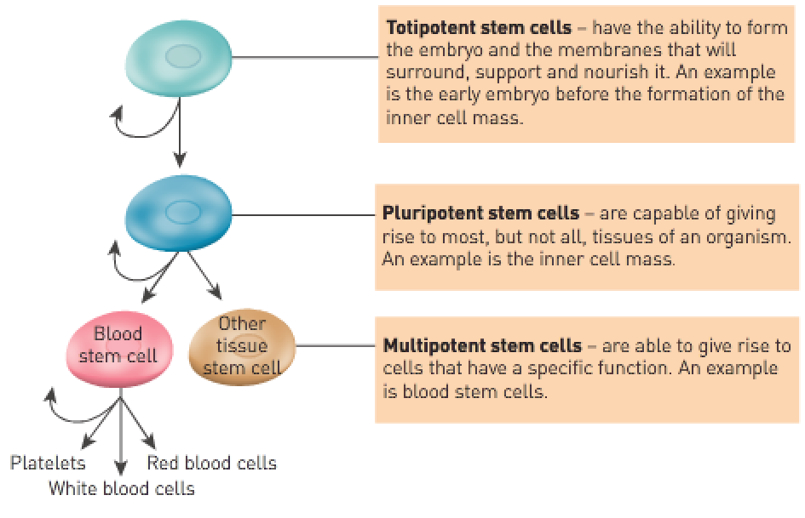
Totipotent | Can give rise to all the cell types that make up the human body and all the cell types that make up the membranes that surround the developing embryo (including the placenta).
Pluripotent | Can give rise to all the cell types that make up the body but not the cell types that make up the embryonic membranes or placenta.
Multipotent | Can develop into more than one of the cell types that make up the body but not all cell types.

Sources of cells:
- Cord blood:
- Multipotent stem cells can be extracted from the umbilical cord or placenta and stored for later use.
- These stem cells can differentiate into any blood cell and are useful for individuals who have bone marrow or blood diseases.
- There’s no harm to parent or baby when these cells are extracted.
- Embryonic stem cells:
- Cultured from frozen embryos obtained from IVF clinics.
- Unused embryos from IVF may be donated to research because the couple no longer desire additional children.
- Has significant ethical issues because obtaining them requires killing of an embryo.
- They come from embryos that aren’t derived from the patient’s own cells so the patient’s body may reject them.
- Adult stem cells:
- Multipotent adult stem cells can form cells of many kinds of tissue.
- A patient’s own cells could be used for treatment so the patient’s body won’t reject them.
- Not as potent as other types of stem cells.

Process of culturing stem cells:
- Cells are extracted from the inner cell mass of the embryo (killing it).
- The 30 cells are harvested and cultured in a dish.
- Over a few days, the cells keep multiplying until the dish is full.
- This subculturing can be repeated many times to provide a source of embryonic stem cells.
- They can also be frozen for use in the future.
- This can also be done with adult stem cells and cord blood.
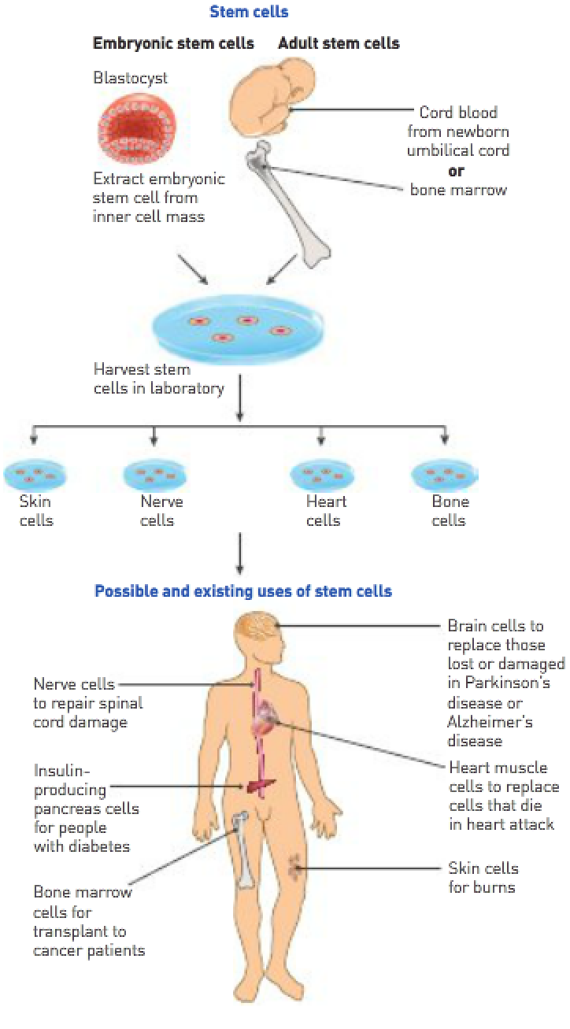
Therapeutic cloning:
- The nucleus from the body cell is inserted into a donor’s egg.
- The donor’s egg has had its nucleus removed.
- A blastocyst with genetically identical information to the nucleus from which it came from is produced.
- Any tissue developed from the stem cells could be transplanted into the patient without the person’s immune system rejecting them.
- Controversial because the embryo, if allowed to develop, would be an identical clone of the patient.
